**CS457L -Week 7**

**http://dev.mysql.com/doc/employee/en/**

**Creating database:**

drop database if exists company;

create database company;

use company;

**Creating tables:**

create table employees(emp_no int not null, birth_date date not null, first_name varchar(14) not null, last_name varchar(16) not null, gender enum('M','F') not null, hire_date date not null, primary key(emp_no));

show tables;

describe employees;

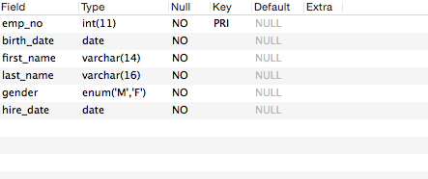

create table departments(dept_no char(4) not null, dept_name varchar(40) not null unique, primary key(dept_no));

describe departments;

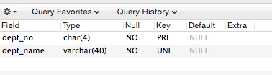

create table dept_manager(dept_no char(4) not null, emp_no int not null, from_date date not null, to_date date not null, foreign key(emp_no) references employees(emp_no) on delete cascade, foreign key(dept_no) references departments(dept_no) on delete cascade, primary key(emp_no, dept_no));

describe dept_manager;

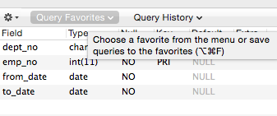

create table dept_emp(emp_no int not null, dept_no char(4) not null, from_date date not null, to_date date not null, foreign key(emp_no) references employees(emp_no) on delete cascade, foreign key(dept_no) references departments(dept_no) on delete cascade, primary key(emp_no, dept_no));

describe dept_emp;

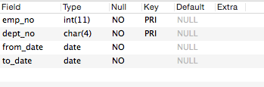

create table titles(emp_no int not null, title varchar(50) not null, from_date date not null, to_date date not null, foreign key(emp_no) references employees(emp_no) on delete cascade, primary key(emp_no, title,from_date));

describe titles;

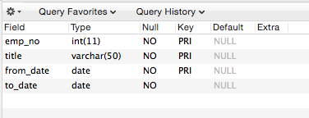

create table salaries(emp_no int not null, salary int not null, from_date date not null, to_date date not null, foreign key(emp_no) references employees(emp_no) on delete cascade, primary key(emp_no, from_date));

describe salaries;

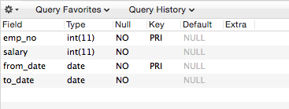

**Importing data to database:**

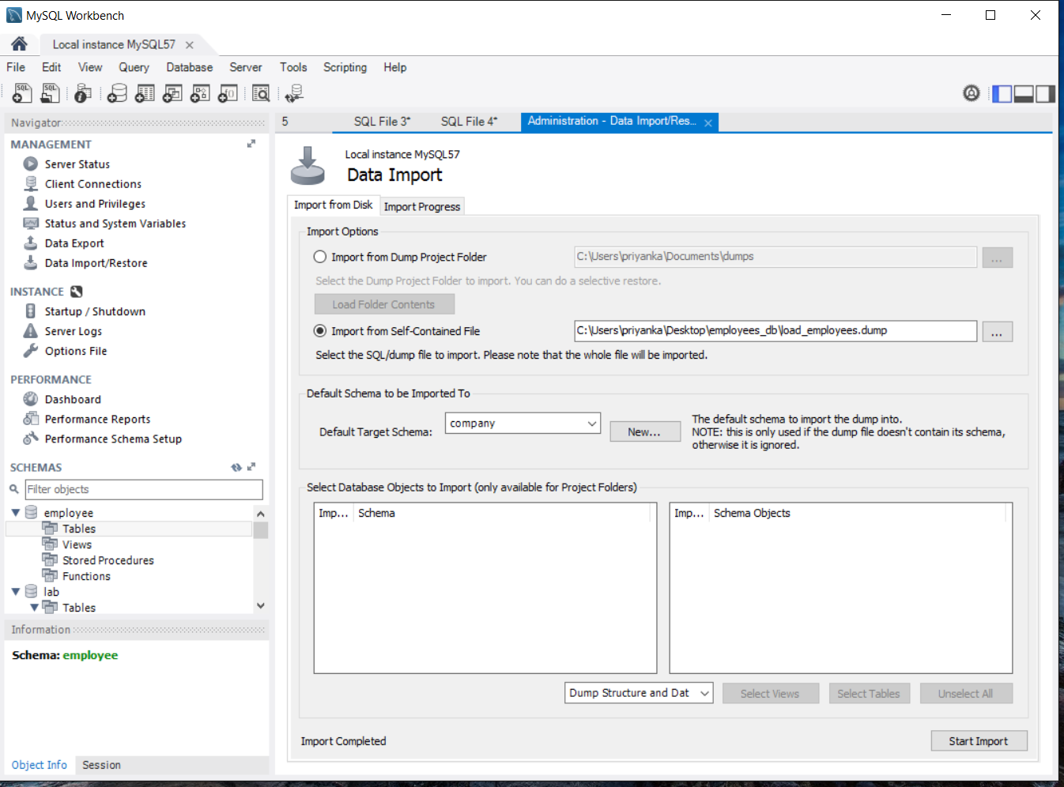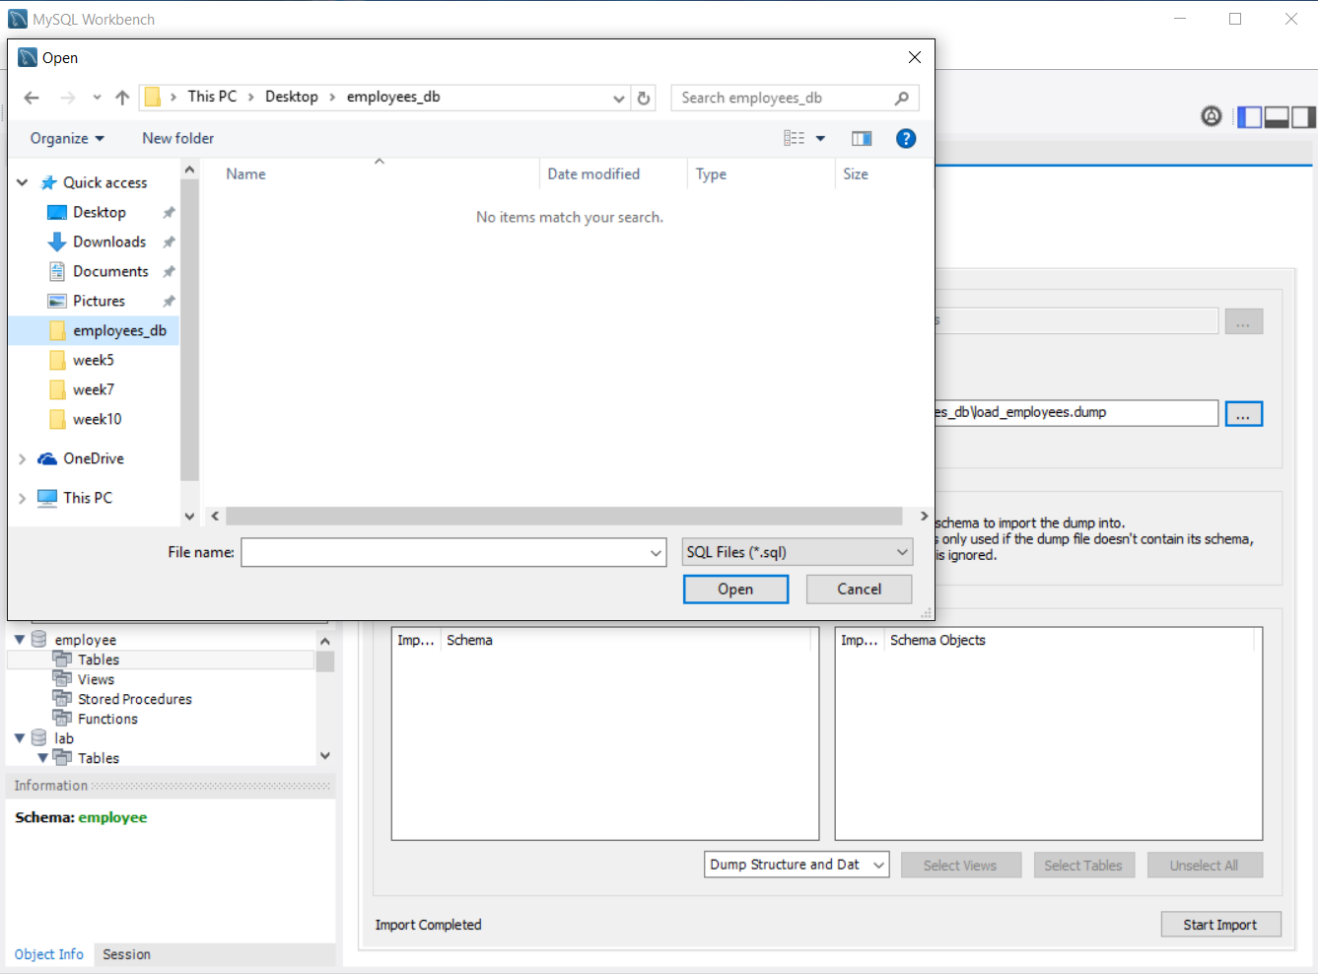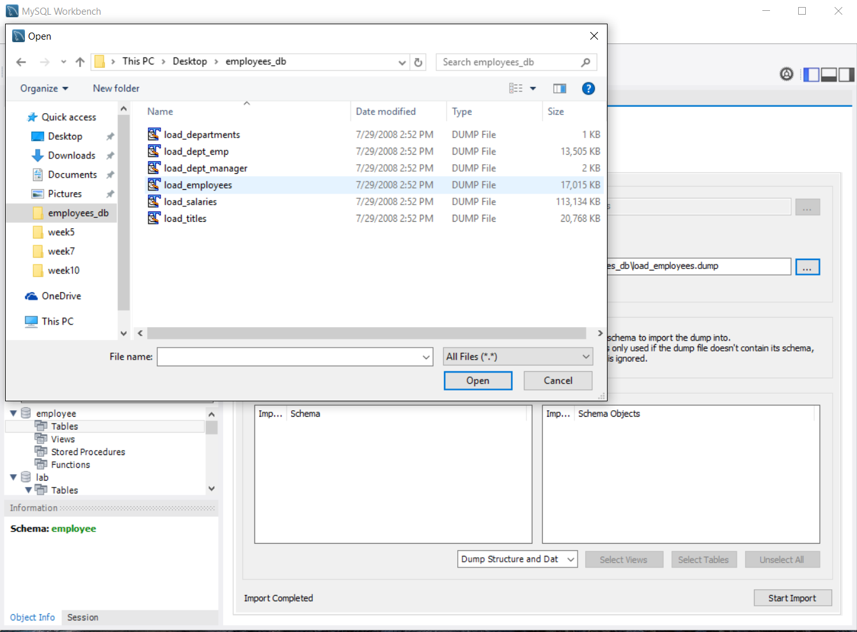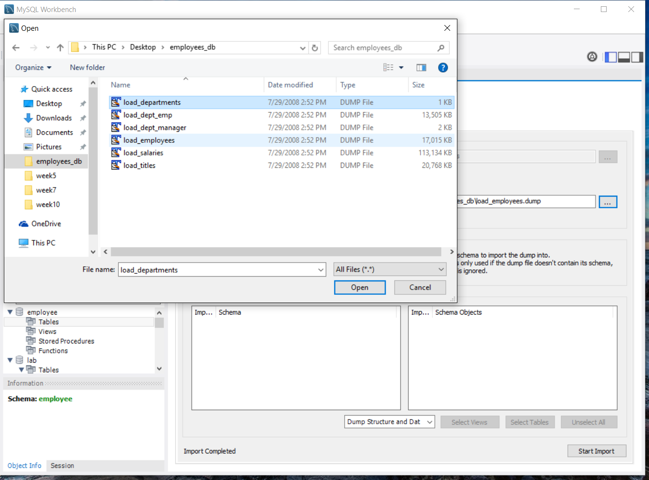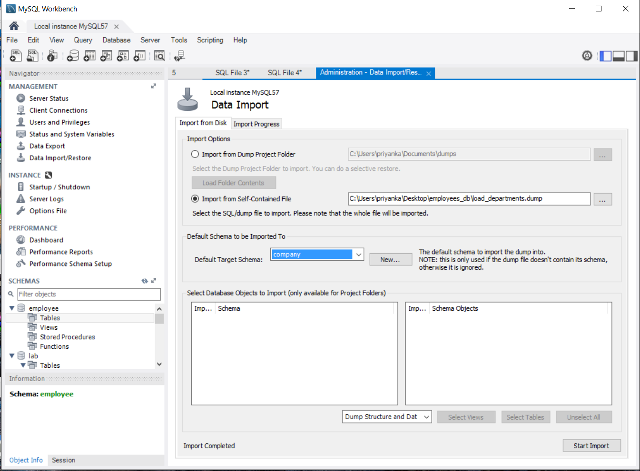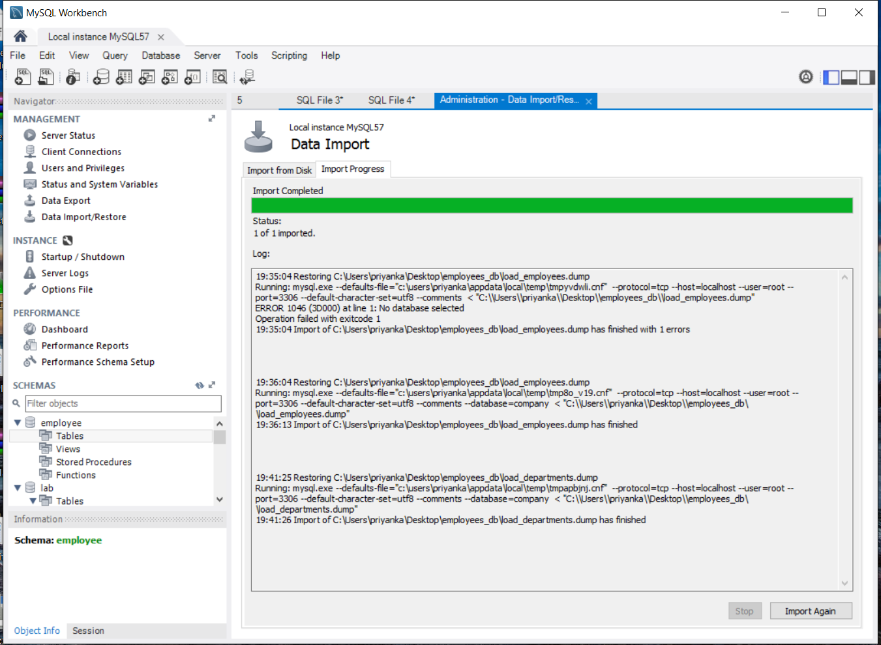

select * from departments;

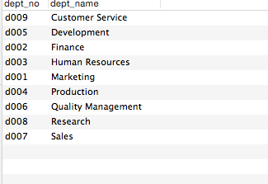

select * from dept_emp;

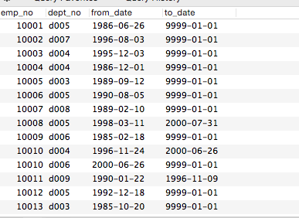

select * from dept_manager;

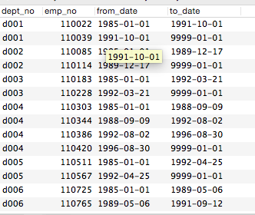

select * from employees;

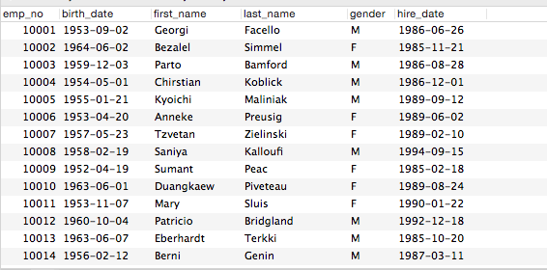

select * from salaries;

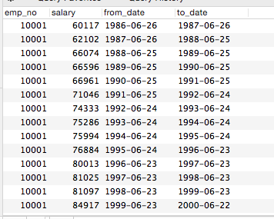

select * from titles;

